SEMKUR-quantitative

This probe operates as a traditional FRET probe (see the chart below). (Add FRET image)

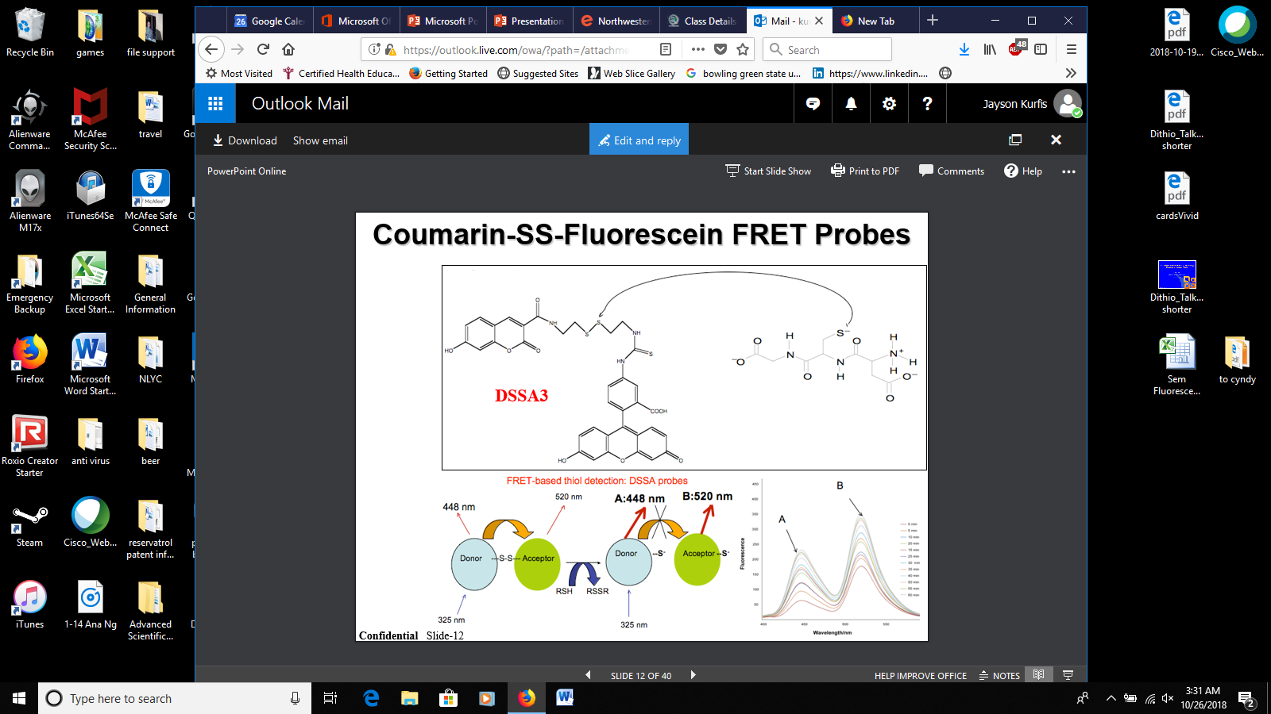

The table below shows the reduction of SEMKUR-quantitative by 2mM Glutathione at an excitation at 325nm.

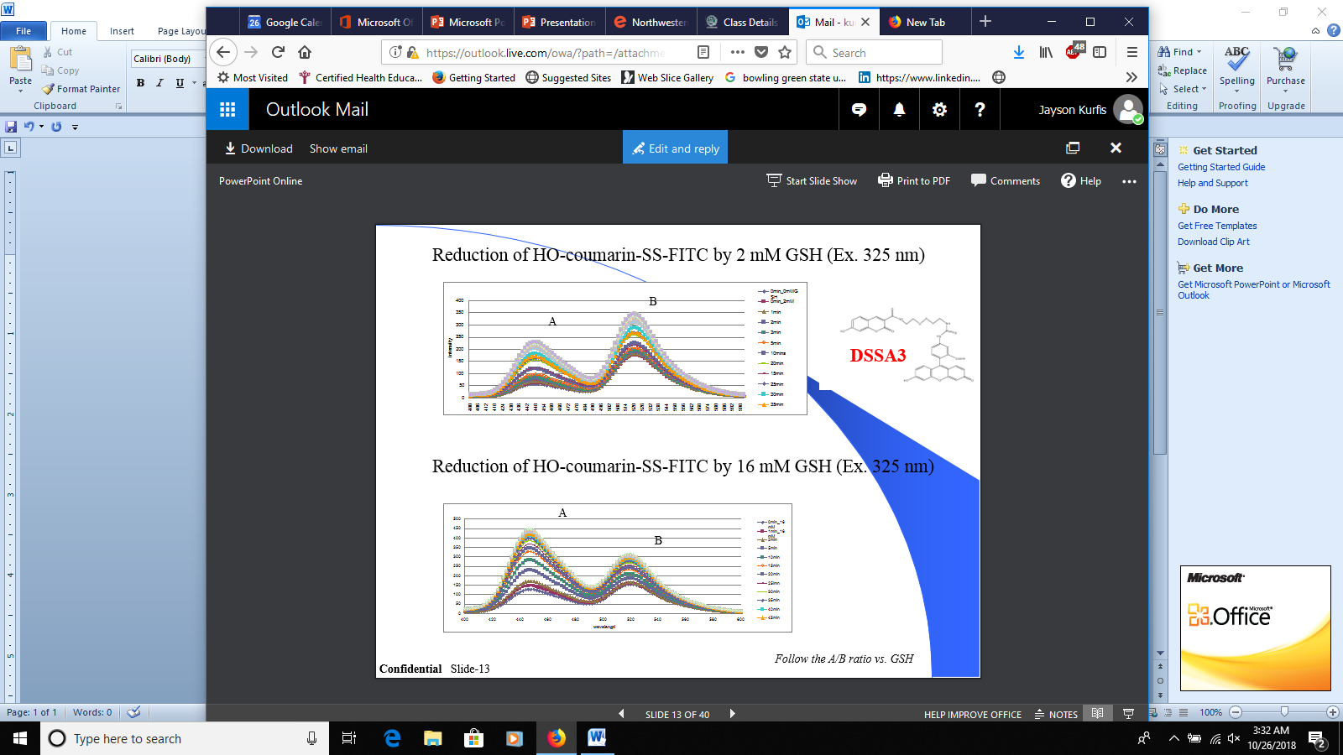

At 16mM glutathione, you can see a very different profile at an excitation of 325nm.



When taking the A/B ratio versus glutathione, you arrive at a standard curve that can be used to ascertain the amount of Glutathione. Glutathione can be used as a way to determine the level of cellular oxidative stress.

